Q&A from October 21, 2020 Webcast
“Coding for CABG/Open Valve and Miscellaneous Heart Procedures”
Q: Weren’t codes 33010-33011 and 33015 Deleted in 2020?
A: You are correct. Slide 51 in the handouts was incorrect and listed those codes. I have fixed that slide and it will be updated in your email blast as well as on our website once the handouts are available.
This is what it should have stated:
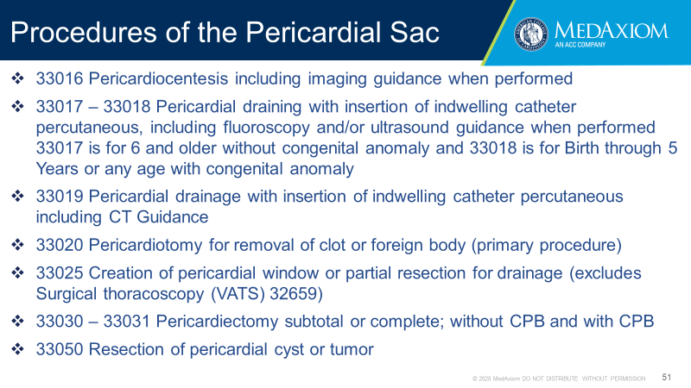

Q: Did you state that the surgeon that initiates the ECMO must also bill the mgmt?
A: No, I stated he could bill for the management if in fact he is the provider managing. More than likely a Cardiologist will take over the management but if not, then the CT surgeon can manage it. Multiple providers however cannot each bill for management only 1 can.

Q: If they have done a previous valve repair and then do a CABG can you code +33530
A: Yes, if it was a previous valve and now it’s a CABG (or vice versa) you may bill the +33530

Q: For clarification, when using 33530, the previous procedure has to be a CABG or Valve and the current procedure has to be a CABG or Valve? For example, if the patient had a previous ASD that required a sternotomy and years later had a CABG or Valve, could we use 33530 in this scenario?
A: I have heard that the STS has changed their stance on this and states any previous cardiac procedure whether done by thoracotomy or sternotomy can now bill for the +33530 as long as the second procedure is a CABG or Valve and it’s more than one month later. I have reached out to the STS to confirm this and have not had a response yet.
According to CPT Guidance which is what I am following there are several assist articles about the 33530 that state it has to be a previous CABG or Valve. My advice is to check with your particular Medicare Carrier as to what their recommendation is. As of now I am keeping in accordance with CPT Guidelines and would only code 33530 if it is a redo CABG or Redo Valve (see below the CPT Assist Articles:

July 2001 page 11
Coding Consultation
Cardiovascular System, Surgery, 33530 (Q&A)
Question
What is add-on code 33530, Reoperation, coronary artery bypass procedure or valve procedure, more than one month after original operation (List separately in addition to code for primary procedure), intended to describe?
AMA Comment
In the instance when a repeat coronary artery bypass procedure or valve procedure is performed, there is increased difficulty. When performing a "redo" operation, a repeat sternotomy is performed. This requires removal of previously placed wire sutures, which may have become embedded in the bony portion of the sternum. The anterior cardiac chambers, great vessels and other mediastinal structures may be densely adherent to the posterior table of the sternum, so the sternal incision must be made with extreme care so as to avoid potentially catastrophic hemorrhage. Once the mediastinum has been entered, the scarring and adhesions from prior surgery may obscure the anatomic landmarks and make dissection both difficult and hazardous. Code 33530 is intended to describe this increased technical difficulty associated with the reoperation.
Code 33530 is reported in addition the primary procedure when the redo operation is performed more than one month after the original operation. Code 33530 should never be reported alone as it is intended to describe the added difficulty as indicated above in performing the "redo" coronary artery bypass procedure or valve procedure. As indicated in the parenthetical note below code 33530 in the CPT manual, this code should be reported in with codes 33400-33496; 33510-33536, or 33863.

February 2005 page 13
Coding Consultation:Questions and Answers
Cardiovascular System/Surgery, 33530, 33400, 33496, 33510, 33536 (Q&A)
Question
Which procedures are considered primary procedures that may be reported with add-on CPT code 33530, Reoperation, coronary artery bypass procedure or valve procedure, more than one month after original operation (List separately in addition to code for primary procedure)?
AMA Comment
From a CPT coding perspective, CPT code 33530 is an add-on code used to report coronary artery bypass or valve reoperation procedures performed more than one month after the original operation. Code 33530 is not reported alone; it is reported in addition to the appropriate code(s) to describe the bypass or valve procedure performed. Code 33530 is reported to reflect the increased difficulty associated with the redo procedure. As indicated in the parenthetical note following code 33530 in the CPT codebook, this code should be reported in addition to codes 33400- 33496, 33510-33536, or 33863. If the code is not listed in this parenthetical note, it may not be reported with CPT code 33530.

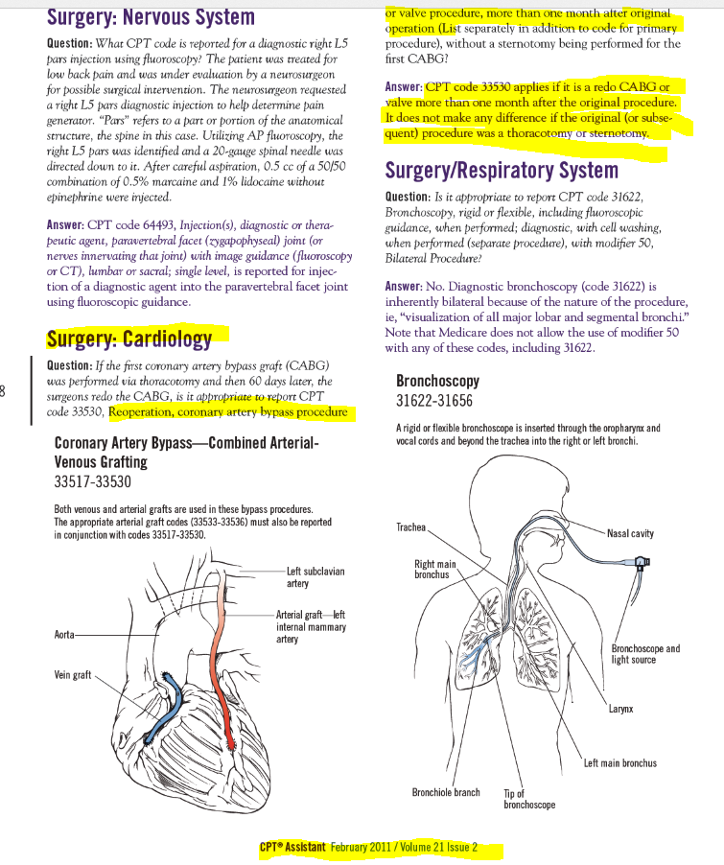

Q: Is documentation of "graft surveillance" - the condition of the SVG after performed appropriate to bill +76998.26.59?
A: No, it would not be appropriate to code this for graft surveillance. Add on code +76998 is only coded when used for checking the patency of the aorta to assist in placing the patient on cardiopulmonary bypass. Anything to do with venous grafts is bundled into the Vein bypass codes.

Q: What does EPI stand for?
A: Epi is a Greek prefix meaning, at, upon, on, near or around etc. I’m assuming you are wondering what Epi-aortic ultrasound guidance means for +76998. The actual description of +76998 is Ultrasonic guidance intraoperative. Many CT surgeons will document that they performed “Epi-Aortic ultrasound guidance” during a CABG or valve etc. Again, it is being performed to check the patency of the aorta for placing the patient on bypass.

Q: Is sliding leaflet repair adequate for 33427?
A: Yes, that would be adequate. 33426 is merely enlarging the diameter of the valve to place a ring. 33427 is a more extensive repair in which there are leaflet repairs or transferring cords from the posterior leaflet to the anterior leaflet. Basically, any repair that is done other than just placing a ring would be considered 33427.

Q: What is the modifier that we would use with the 21750 if the sternum is left open and then closed a couple of days later?
A: Modifier 58 is for staged or related procedure during a global period. If the patient leaves the OR with an open Sternum and the physician plans to bring them back later to close, then you should use 58. If however patient is in a global time frame and the sternum becomes dehisced then you should use the 78 modifier.

Q: What procedure code would I use for a Repair of left ventricular pseudoaneurysm with pericardial patch?
A: Without seeing actual documentation, if it is done with a CABG more than likely you would code the 33542.

Q: When there is an endarterectomy and they say it is of an obtuse marginal, do we pick that up because it is of the Left Circumflex OR do we only pick up endarterectomies that say only LAD, RC or Circumflex. Some doctors want the endarterectomy coded no matter what.

A: The STS has sited endarterectomy is for Left Anterior Descending, Circumflex, Right Coronary, PDA or Marginal. The +33572 has an MUE of 3. I would not code a branch and a main artery both. So, I would not code the Marginal and Circumflex both.

Q: What would you recommend for documentation of limited coronary endarterectomy of 1 or more of the specified arteries?
A: I’m not positive I completely understand the question, but there is no specific requirement of how much must be endarterectomized in order to code the +33572.

Q: Do you have an example where there was a NP or PA assisting, with how to document and code for physician and for the NP or PA?
A: It doesn’t have to be lengthy. Just a statement as to what the physician assistant performed such as: “The physician assistant assisted on the entire case, harvested the saphenous vein and closed the chest”
Then you would code what the surgeon coded with the AS modifier attached to the codes that allow for assistants.

Q: For ECMO If a physician creates a conduit from above the femoral artery to below to jump pass the cannula so that the foot perfusion remains intact, code?
A: Without seeing specific documentation I would look at code +33987 it is for a chimney graft to facilitate arterial perfusion

Q: If during a CABG, the surgeon procures a radial artery endoscopically as well as a SVG endoscopically, how would you report this? Thank you
A: Your codes would be +35600 for the radial artery and +33508 for endoscopic vein harvest.

Q: For artery harvest, it shows mue of 2 - can we charge x 2 if documented?

A: Yes, it would be coded twice.

Q: What dx code do you use most for valvuloplasty?
A: You must code to the condition that the patient has; but it should be some type of valve anomaly such as stenosis, regurgitation, rheumatic, congenital etc. There are no NCD’s for open valvuloplasty.
Q: What code do you use for TEE sizing for LAA preop for a fib?
A: I would rather see documentation before recommending a code. The code would be determined by what role the surgeon did or did not play in the TEE. Did he perform the TEE or just the interp. Has medical necessity been met? Etc.
Q: If the provider does not document the additional work for modifier 22 would you report it as an unlisted code?

A: I’m not sure of the scenario we are talking about so without further explanation I decline to comment on this question, You may email me with specifics at jbruder@medaxiom.com

